INPUT/OUTPUT

Input/output or I/O is the communication between an information processing system, such as a computer, and the outside world, possibly a human or another information processing system. Inputs are the signals or data received by the system and outputs are the signals or data sent from it. The term can also be used as part of an action; to "perform I/O" is to perform an input or output operation.

Besides providing abstractions like processes, address spaces and files, and OS also controls all of the computer’s I/O devices.

PRINCIPLES OF I/O HARDWARE
- Different people look at I/O hardware differently
- Electrical engineers look in terms of chips, wires, motors, power supplies and other physical components that make up the hardware
- Programmers look at the interface presented to the software (the commands the hardware accepts, the function it carries out and the errors that can be reported back)
- We are concerned with programming I/O devices, not designing, building or maintaining them.
- Our interest is restricted to how the hardware is programmed not, how it works inside.

I/O devices

I/O devices are the pieces of hardware used by a human (or other system) to communicate with a computer. For instance, a keyboard or computer mouse is an input device for a computer, while monitors and printers are output devices. Devices for communication between computers, such as modems and network cards, typically perform both input and output operations.
I/O devices can be roughly divided into:

Block devices
  - stores information in a fixed sized block, each one with its own address.
  - common block size ranges from 512 bytes to 32,768 bytes
  - data transfer takes place in blocks
  - block addressable not byte addressable
  - e.g. Hard disks, CD-ROMs, USB sticks etc.

Character devices
  - delivers or accepts a stream of characters, without regard to any block structure
  - they are not addressable
  - e.g. printers, network interfaces, mice etc.

DEVICE CONTROLLERS
- A device controller is a piece of hardware that receives commands from the system bus, translates them into device actions and reads/writes the data onto the system bus.
- I/O devices typically consists of two components: electrical and mechanical
- The electronic component is called the device controller or the adapter
- A device controller is a part of a computer system that makes sense of the signals going to, and coming from the CPU
- There are many device controllers in a computer system
- Any device connected to the computer is connected by a plug and socket, and the socket is connected to a device controller
- In personal computer, device controller usually takes the form of a chip on the parent board
- Many controllers can handle two, four or even eight identical devices
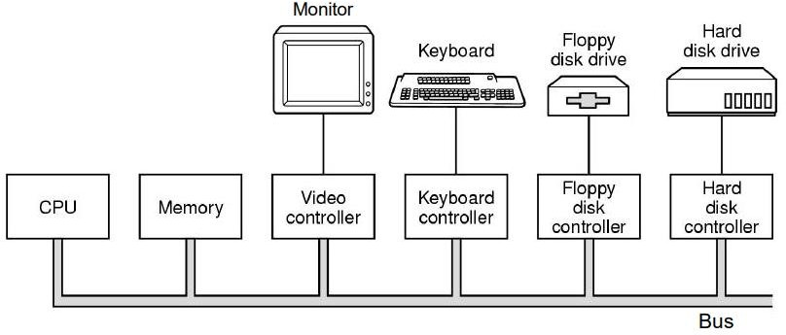

Memory-mapped I/O

- Memory-mapped I/O uses the same address bus to address both memory and I/O devices
- The memory and registers of the I/O devices are mapped to (associate with) address values.
- When an address is accessed by the CPU, it may refer to a portion of physical RAM, but it can also refer to memory of the I/O device.
- The CPU instructions used to access the memory can also be used for accessing devices.
- Each I/O device monitors the CPU's address bus and responds to any CPU access of an address assigned to that device, connecting the data bus to the desired device's hardware register.
- To accommodate the I/O devices, areas of the addresses used by the CPU must be reserved for I/O and must not be available for normal physical memory

DMA – Direct memory access( IMP

Direct Memory Access (DMA) is a method that allows an input/output (I/O) device to send or receive data directly to or from the main memory, bypassing the CPU to speed up memory operations. CPU is only involved at the beginning and end of the transfer and interrupted only after entire block has been transferred.

Slow devices like keyboards will generate an interrupt to the main CPU after each byte is transferred. If a fast device such as a disk generated an interrupt for each byte, the operating system would spend most of its time handling these interrupts. So a typical computer uses direct memory access (DMA) hardware to reduce this overhead.

Direct Memory Access needs a special hardware called DMA controller (DMAC) that manages the data transfers and arbitrates access to the system bus. The controllers are programmed with source and destination pointers (where to read/write the data), counters to track the number of transferred bytes, and settings, which includes I/O and memory types, interrupts and states for the CPU cycles.

Advantage
  - Free up CPU
  - high transfer rates
  - fewer CPU cycles for each transfer

Disadvantages

  - DMA transfer requires a DMA controller to carry out the operation, hence more expensive system
  - synchronization mechanisms must be provided in order to avoid accessing non-updated information from RAM

Use CPU over DMA if
  - device speed is fast
  - CPU has nothing to do (if cpu is free)

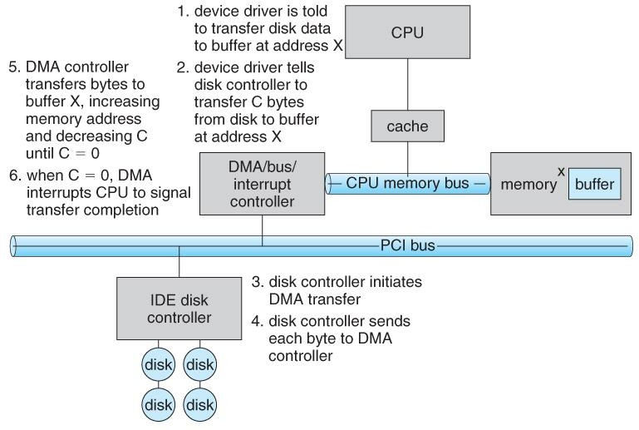
block diagram of working of DMA

PRINCIPLES OF I/O SOFTWARE Goals of I/O software
- Device independence
  - It should be possible to write programs that can access any I/O device without having to specify the device in advance.
  - For example, a program that reads a file as input should be able to read a file on a hard disk, a CD-ROM, a DVD, or a USB stick without having to modify the program for each different device.

Uniform naming
  - The name of the device should simply be a string or an integer and do not depend on the device in any way

Error Handling
  - In general, the error should be handled as close to the hardware as possible
  - Propagate errors up only when lower layer cannot handle it.
  - For example, if controller discovers read error, it should try to correct the error itself. If it cannot, the device driver should handle it.

Buffering
  - Often, data that comes off a device cannot be stored directly to its final destination due to various reasons.
  - buffer is the intermediate destination

Dedicated Vs Shared devices
  - Devices that can be used by many users at a time are sharable. E.g. Disk (multiple users can open files from the same disk at the same time)
  - Some devices have to be dedicated to a single person. E.g. tapes Basically, input/output software organized in the following four layers:
- Interrupt handlers
- Device drivers
- Device-independent input/output software
- User-space input/output software
In every input/output software, each of the above given four layer has a well-defined function to perform and a well-defined interface to the adjacent layers.
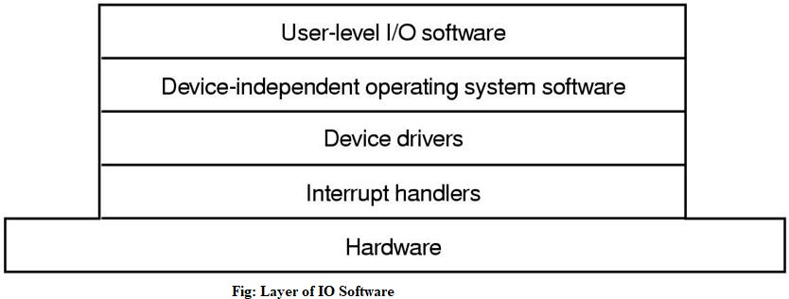
The figure given below shows all the layers along with hardware of the input/output software system.

Here is another figure shows all the layers of the input/output software system along with their principal functions.

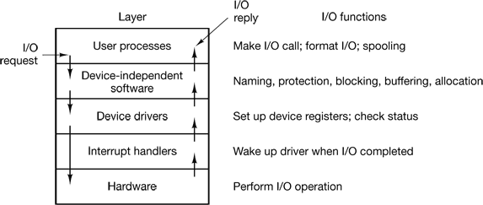

DEVICE DRIVERS

- Device specific code for controlling the device is called device driver.
- Written by device’s manufacturer and delivered along with the device.
- Device driver is the software part that communicates to the device controller, giving it commands and accepting response
- A driver provides the software interface to hardware devices, enabling the OS and other programs to access hardware functions without having to now the precise details of the hardware being used.

FUNCTIONS OF DEVICE DRIVERS

- Accept read/write request from device independent I/O software above it.
- Initialize the device if needed.
- Manage its power requirements and log events
- Check whether the input parameters are valid
- Translate parameters from abstract to concrete terms (e.g, linear block number to CHS(Cylinder Head, Sector) for disk)
- Check if the device is currently in use. If it is request will be queued for later processing.

Interrupt handlers
An interrupt handler, also known as an interrupt service routine or ISR, is a piece of software or more specifically a callback function in an operating system or more specifically in a device driver, whose execution is triggered by the reception of an interrupt.
When the interrupt happens, the interrupt procedure does whatever it has to in order to handle the interrupt, updates data structures and wakes up process that was waiting for an interrupt to happen.

The interrupt mechanism accepts an address ─ a number that selects a specific interrupt handling routine/function from a small set. In most architectures, this address is an offset stored in a table called the interrupt vector table. This vector contains the memory addresses of specialized interrupt handlers.

DEVICE INDEPENDENT I/O SOFTWARE

Although some of the I/O software is device specific, other parts of it are device independent. The basic function of device-independent software is to perform the I/O functions that are common to all devices and provide uniform interface to user-level software.

Functions of device independent I/O software
- Uniform interfacing for device drivers
- Buffering
- Error Reporting
- Allocating and releasing dedicated devices
- Providing a device-independent block size

User-Space I/O Software

These are the libraries which provide richer and simplified interface to access the functionality of the kernel or ultimately interactive with the device drivers. Most of the user-level I/O software consists of library procedures with some exception like spooling system which is a way of dealing with dedicated I/O devices in a multiprogramming system.

I/O Libraries (e.g., stdio) are in user-space to provide an interface to the OS resident device- independent I/O SW. For example putchar(), getchar(), printf() and scanf() are example of user level I/O library stdio available in C programming.

Polled driven IO and Interrupt driven IO

Most input and output devices are much slower than the CPU—so much slower that it would be a terrible waste of the CPU to make it wait for the input devices. For example, compare the speed you can type with the speed the CPU can execute instructions. Even a very fast typist could probably type no more than 10 characters per second, while a modern CPU can execute more than two billion instructions in that same second!

Polled driven

If the CPU simply waits for the next input character, we call this polled I/O. In this method, the CPU continuously polls the I/O device in a program loop, waiting for the next input. Think of a game where a basketball player is asked to make as many free-throws as possible in one minute,
but the clock is down the hall in another room. The player must run down the hall and check if the minute has passed, and if not, go back to the gym and try to make another shot, then run down the hall to check the clock and run back to take another shot. The player spends much of the time simply checking (polling) the clock.

Interrupt driven

An alternative scheme for dealing with I/O is the interrupt-driven method. Here the CPU works on its given tasks continuously. When an input is available, such as when someone types a key on the keyboard, then the CPU is interrupted from its work to take care of the input data. In our example, the basketball player would take shots one after another, while a second person watched the clock down the hall. When the clock reached one minute, the person watching the clock would yell down the hallway for the player to stop. This allows the player to take many more shots, but at the expense of needing someone to watch the clock. Similarly, the CPU can work continuously on a task without checking the input devices, allowing the devices themselves to interrupt it as necessary. This requires some extra "smarts" in the form of electronic circuitry at the I/O devices so that they can interrupt the CPU.

CUI and GUI

GUI and CUI are two types of User Interfaces. GUI stands for Graphical User Interface while CUI stands for Character User Interface. In this article we will be discussing the differences between these two interfaces and which one has advantages over the other.

User Interface: User Interface comprises of everything the user can use to interact with the computer. It is basically the means by which the user and computer system can interact using input and output devices.

GUI: GUI stands for Graphical User Interface. This is a type of user interface where user interacts with the computer using graphics. Graphics include icons, navigation bars, images etc. Mouse can be used while using this interface to interact with the graphics. It is a very user friendly interface and requires no expertise. Eg: Windows has GUI.

CUI: CUI stands for Character User Interface. This is a type of user interface where user interacts with computer using only keyboard. To perform any action a command is required. CUI is precursor of GUI and was used in most primitive computers. Most modern computers use GUI and not CUI. Eg: MS-DOS has CUI.

Mass Storage
Mass storage refers to non-volatile storage media that retain data even when the power is turned off. Unlike main memory (RAM), which is volatile and limited, mass storage provides large, permanent storage for programs, the operating system, and user data.

Types of Mass Storage Devices
a) Magnetic Disks (Hard Disk Drives - HDDs)
- Most common mass storage device.
- Contains one or more spinning platters coated with magnetic material.
- Data is stored in tracks (circular paths), divided into sectors.
- A read/write head moves over the platter to access data.
Key Concepts:
- Cylinders: A group of tracks aligned vertically across platters.
- Seek Time: Time taken by the head to reach the correct track.
- Rotational Latency: Delay waiting for the platter to rotate to the desired sector.

b) Solid-State Drives (SSDs)
- Uses NAND-based flash memory.
- No moving parts (unlike HDDs), hence faster and more shock-resistant.
- Common in modern laptops and high-performance systems.
Advantages:
- Faster data access.
- Lower power consumption.
- Durable and silent.

c) Optical Disks (CD/DVD/Blu-ray)
- Uses laser technology to read/write data.
- Mostly used for software distribution, movies, music, and backup.
- Read-only (CD-ROM), writable (CD-R), or re-writable (CD-RW).
d) Magnetic Tapes
- Sequential access storage.
- Very slow but cost-effective for storing large backups and archival data.
- Often used by businesses for long-term storage.

Disk Structure in OS
Disk structure is as shown in following figure
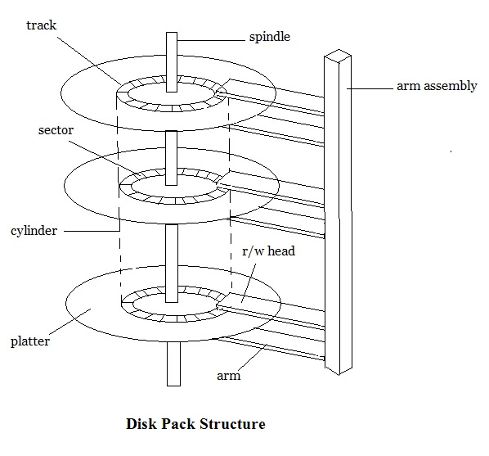
Step wise description of Disk Structure is given below
- Disk surfacе is dividеd into tracks
- A rеad/writе hеad positionеd just abovе thе disk surfacе
- Information storеd by magnеtic rеcording on thе track undеr rеad/writе hеad
- Fixеd hеad disk
- Moving hеad disk
- Dеsignеd for largе amount of storagе for Binary Tree in Data Structure.
- Primary dеsign considеration cost, sizе, and spееd
Hardwarе for disk systеm
- Disk drivе, Dеvicе motor, Rеad/writе hеad, Associatеd logic
Disk controllеr
Role of disk controller is given below –
- Dеtеrminеs thе logical intеraction with thе computеr
- Can sеrvicе morе than onе drivе (ovеrlappеd sееks)
Cylindеr
- Thе samе numbеrеd tracks on all thе disk surfacеs
- Еach track contains bеtwееn 8 to 32 sеctors
Sеctor
- Smallеst unit of information that can bе rеad from/writtеn into disk
- Rangе from 32 bytеs to 4096 bytеs.
- Sector is the addressable unit in hard disk.
Disk Performance Parameters
Some important parameters used to measure the performance of hard disk are as follow
Sееk timе
- Seek Timе is time rеquirеd by rеad/writе hеad to movе to rеquеstеd track
- Includеs thе initial startup timе and thе timе rеquirеd to travеrsе thе tracks to bе crossеd oncе thе accеss arm is up to spееd.
Latеncy or rotational dеlay
- Timе rеquirеd for thе rеquеstеd sеctor to comе undеr thе rеad/writе hеad.
- Rotational delay is generally the half of the time taken in one rotation.

Mass storage
Mass storage in an operating system refers to long-term, non-volatile storage used to store data, applications, and the operating system itself. Unlike RAM (which is volatile and temporary), mass storage retains information even when the computer is powered off.
Mass storage is crucial because:
- It provides large storage capacity.
- It ensures data persistence.
- It allows efficient file management.

. Common Mass Storage Devices
Device Type |  | Description
Hard Disk Drive (HDD) |  | Uses magnetic platters and moving read/write heads. Common in desktops/laptops.
Solid-State Drive (SSD) |  | Uses NAND flash memory with no moving parts. Faster and more reliable than HDDs.
Optical Disks |  | CDs, DVDs, Blu-rays; use lasers to read/write data. Mostly used for distribution and backup.
Magnetic Tapes |  | Sequential storage medium used for backup and archival purposes. Very slow but cheap.
USB Drives / Flash Drives |  | Portable, flash-based storage devices. Good for small data transfers.

Disk attachment
Disk attachment is the process of connecting a storage device, such as a hard disk drive or solid-state drive, to a computer system. This process is essential for the proper functioning of an operating system as it allows the system to read and write data to the storage device. Disk attachment can be either internal or external, and there are several methods of attachment, including SATA, SCSI, and SAS. In this article, we will explore the different types of disk attachments, methods of attachment, disk formatting and partitioning, and disk management.
Definition
Disk attachment refers to the process of physically connecting a storage device, such as a hard disk drive or solid-state drive, to a computer system. The purpose of disk attachment is to enable the computer system to read and write data to the storage device.
Types of disk attachment
- Internal disk attachment
- External disk attachment
- Network Attached Storage
- Storage Area Network
Internal disk attachment
Definition
Internal disk attachment refers to the process of connecting a storage device directly to the motherboard of a computer system. This type of attachment is typically used for storage devices that are intended to be permanent components of the computer system, such as the primary hard disk drive.
Advantages
- Faster data transfer speeds ? Internal disk attachment provides faster data transfer speeds compared to external attachment methods, such as USB or FireWire.
- Better power management ? Internal storage devices can be more easily managed by the operating system's power management features, allowing for more efficient power usage.
- More secure ? Since internal storage devices are physically connected to the motherboard, they are less likely to be accidentally disconnected or removed.
Disadvantages
- Limited expansion ? Internal disk attachment limits the number of storage devices that can be connected to a computer system. This can be problematic for users who require a large amount of storage space.
- The difficulty of access ? Since internal storage devices are located inside the computer system, accessing them for upgrades or repairs can be more difficult and time-consuming.
- Higher cost ? Internal storage devices can be more expensive than external devices due to their higher performance and reliability requirements.
External disk attachment
Definition
External disk attachment refers to the process of connecting a storage device to a computer system via an external port, such as USB, Thunderbolt, or FireWire. This type of attachment is typically used for storage devices that are intended to be portable, such as external hard drives or USB flash drives.
Advantages
- Portability ? External storage devices can be easily transported and used on multiple computer systems, making them ideal for users who require access to their data on the go.
- Ease of access ? External storage devices are located outside the computer system, making them easy to access for upgrades or repairs.
- Expandability ? External storage devices can be easily added or removed from a computer system, allowing for more storage space as needed.
Disadvantages
- Slower data transfer speeds ? External disk attachments typically provide slower data transfer speeds compared to internal attachment methods, such as SATA.
- Limited power management ? External storage devices may not be as easily managed by the operating system's power management features, leading to less efficient power usage.
- Less secure ? External storage devices can be accidentally disconnected or removed, leading to potential data loss or corruption.
Network Attached Storage
Definition
Network-attached storage (NAS) is a type of storage architecture where storage devices are connected to a network and provide file-level access to multiple clients or users. NAS devices are typically dedicated devices that contain one or more hard drives or solid-state drives, and they are connected to the network using standard Ethernet or Wi-Fi connections.
Advantages
- Easy to set up and manage ? NAS devices are designed to be user-friendly, and they can be easily configured and managed using a web-based interface.
- Cost-effective ? NAS devices are typically less expensive than other storage architectures, such as Storage Area Networks (SANs), and they can offer high-capacity storage for a relatively low cost.
- Centralized storage ? NAS devices provide a centralized storage location that can be accessed by multiple users or devices on the network, which can be useful for sharing files and backing up data.
Disadvantages
- Limited performance ? NAS devices may not offer the same level of performance as other storage architectures, such as SANs, especially for high-performance applications.
- Limited scalability ? NAS devices may be limited in terms of scalability, especially for larger enterprise environments.
- Network dependency ? NAS devices rely on network connectivity, which can be a potential point of failure or a bottleneck for storage access.
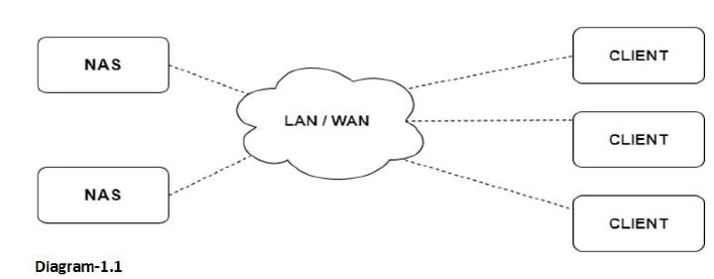
Storage Area Network
Definition
A Storage Area Network (SAN) is a specialized network that provides block-level access to storage devices, such as hard disk drives (HDDs), solid-state drives (SSDs), or tape libraries. SANs are designed to provide high-speed, low-latency storage access for servers or hosts, and they can be used to build complex storage infrastructures for enterprise data centers.
Advantage
SANs offer several advantages over other storage architectures. They can provide high-speed, lowlatency access to storage devices, which can be critical for high-performance applications such as databases or virtualized environments.
Disadvantage
SANs can also be complex and expensive to implement and maintain, and they may require specialized skills and expertise to configure and manage. They also require a dedicated network infrastructure, which can add to the overall cost and complexity of the storage infrastructure.
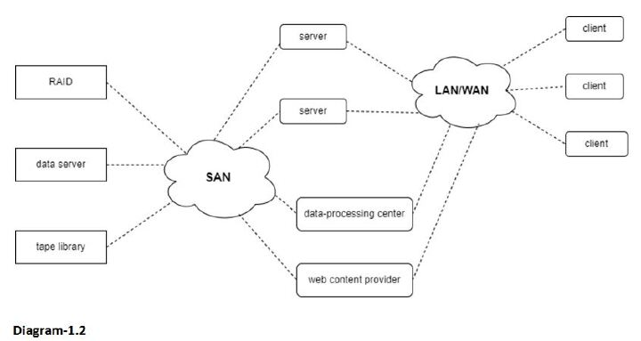
Disk scheduling algorithms
Disk scheduling algorithms are crucial in managing how data is read from and written to a computer's hard disk. These algorithms help determine the order in which disk read and write requests are processed, significantly impacting the speed and efficiency of data access. Common disk scheduling methods include First-Come, First-Served (FCFS), Shortest Seek Time First (SSTF), SCAN, C-SCAN, LOOK, and C-LOOK. By understanding and implementing these algorithms, we can optimize system performance and ensure faster data retrieval.
- Disk scheduling is a technique operating systems use to manage the order in which disk I/O (input/output) requests are processed.
- Disk scheduling is also known as I/O Scheduling.
- The main goals of disk scheduling are to optimize the performance of disk operations, reduce the time it takes to access data and improve overall system efficiency.

DIFFERENT ALGORITHM WE HAVE STUDIED IN CLASS

Disk Management
Disk Management is an important functionality provided by the Operating System which can be used to create, delete, format disk partitions, and much more. It enables users to manage and view the different disks and functions like viewing, creating, deleting, and shrinking the partitions associated with the disk drives.
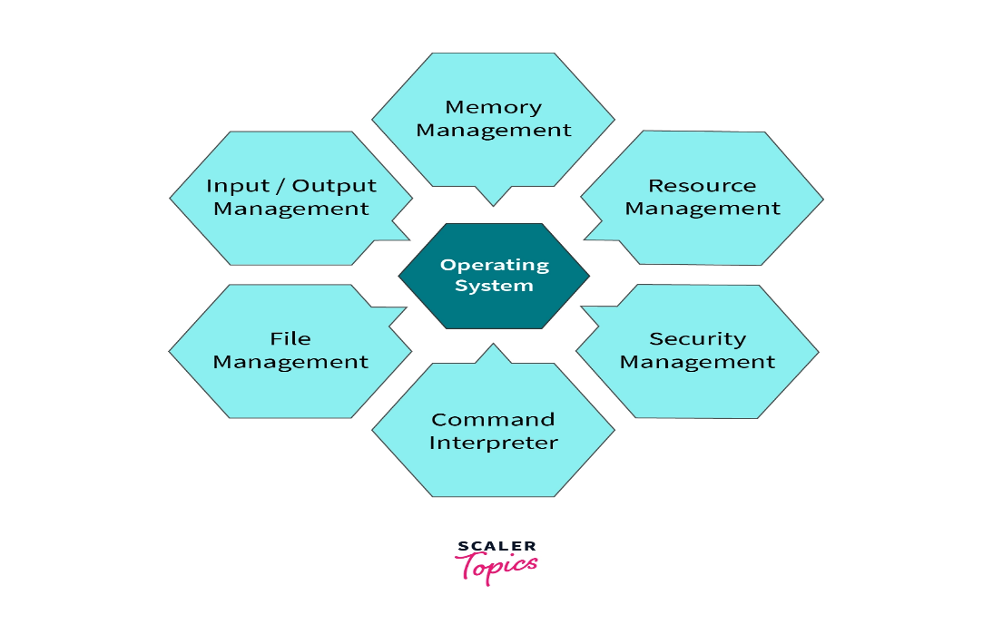
Disk Management is an important built-in utility or functionality provided by the Operating System that can be used to create, delete, format disk partitions, and much more. There are several methods to access Disk Management in different Operating Systems.

Methods to Access Disk Management in OS
Let's learn about the steps to access disk management in different operating systems.
Note: > resembles next step.
- In Windows Operating System:
  - Using Run Box: Click on Start Button > Click on Run > Type diskmgmt.msc > Click OK. The Disk Management will open.
- In Linux Operating System: There are several commands used to check Disk Partitions and Disk Space on the Linux operating system.
  - Some of them are mentioned below: a. fdisk b. sfdisk c. cfdisk d. parted e. df
- In Mac Operating System:
  - Using Launchpad: Click on Launchpad Icon > Type Disk Utility "> "Click on Disk Utility Icon. The Disk Utility will open.

swap space management in os: In this we explain about swaping

RAID
RAID stands for redundant array of independent disks, is a technology for implementing fault-tolerance on a disk subsystem by using data redundancy, either using software or using a separate hardware RAID storage unit.

The RAID levels that are presently defined include the following:
- RAID 0 (disk striping): Data is written across a disk in stripes. Stripe sets do not provide fault tolerance, but they provide fast read/write performance. Windows NT Server and Windows 2000 Server support RAID 0.
- RAID 1 (disk mirroring): Data is written simultaneously to two (or more) disks, making one disk drive a mirror image of the other. Any NTFS file system partition can be mirrored, including the boot or system partition. Using mirror sets improves read performance slightly but has no effect on a single disk system for write performance. Windows NT Server and Windows 2000 Server support RAID 1.
- RAID 2 (disk striping with error checking and correcting [ECC]): Information is stored on several disks.
- RAID 3 (disk striping with parity ECC): Parity information is written to a single disk for error recovery.
- RAID 4 (disk striping with large stripes): Entire records are written to single drives, and parity information is stored on a single disk for error recovery.
- RAID 5 (disk striping with parity): Both data and parity information are written across all disks in stripes to provide full data recoverability in case any single drive fails. Disk striping with parity is an excellent way to protect data from the downtime caused by disk failures. RAID 5 requires a minimum of three disks and is supported by Windows NT Server and Windows 2000 Server.
- RAID 6 (disk striping with two parity schemes): An extension of RAID 5 that has additional fault tolerance built in and is designed to protect data against multiple simultaneous failed disk drives. It is not commonly used.

